Simple Currency Exchange Rate App

This app contains of 3 Docker containers

* Postgres container
* RabbitMQ container
* Django app alongside celery container

The configurations of Docker contianers can be found in docker-compose.yml file.

To run the app follow these steps:

1-change ALPHA_VENTAGE_KEY located in /currency/.env

2-run docker-compse up.

3-go and make some coffee.

You can use app in two ways:

1-Using buttons located in localhost:8000

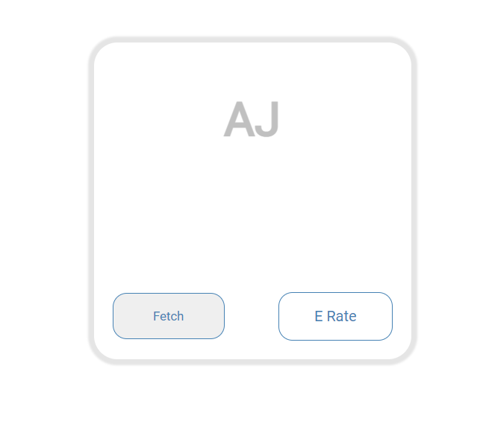

**Fetch: will fetch and store new API record in database.**

**E Rate: will get last stored exchange rate.**

2-Using Postman or any other tool to send HTTP requests

**Post method**

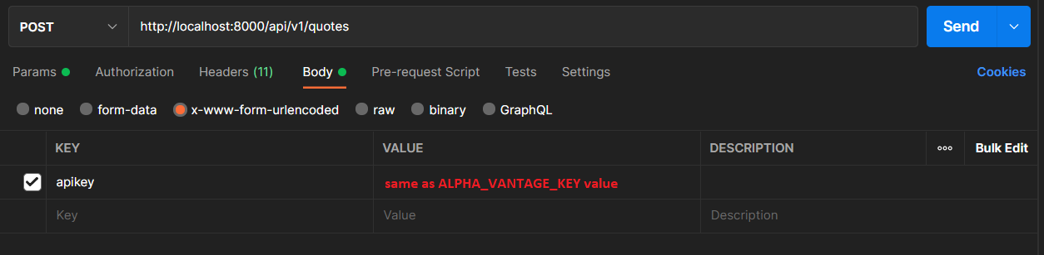

**Get method**

